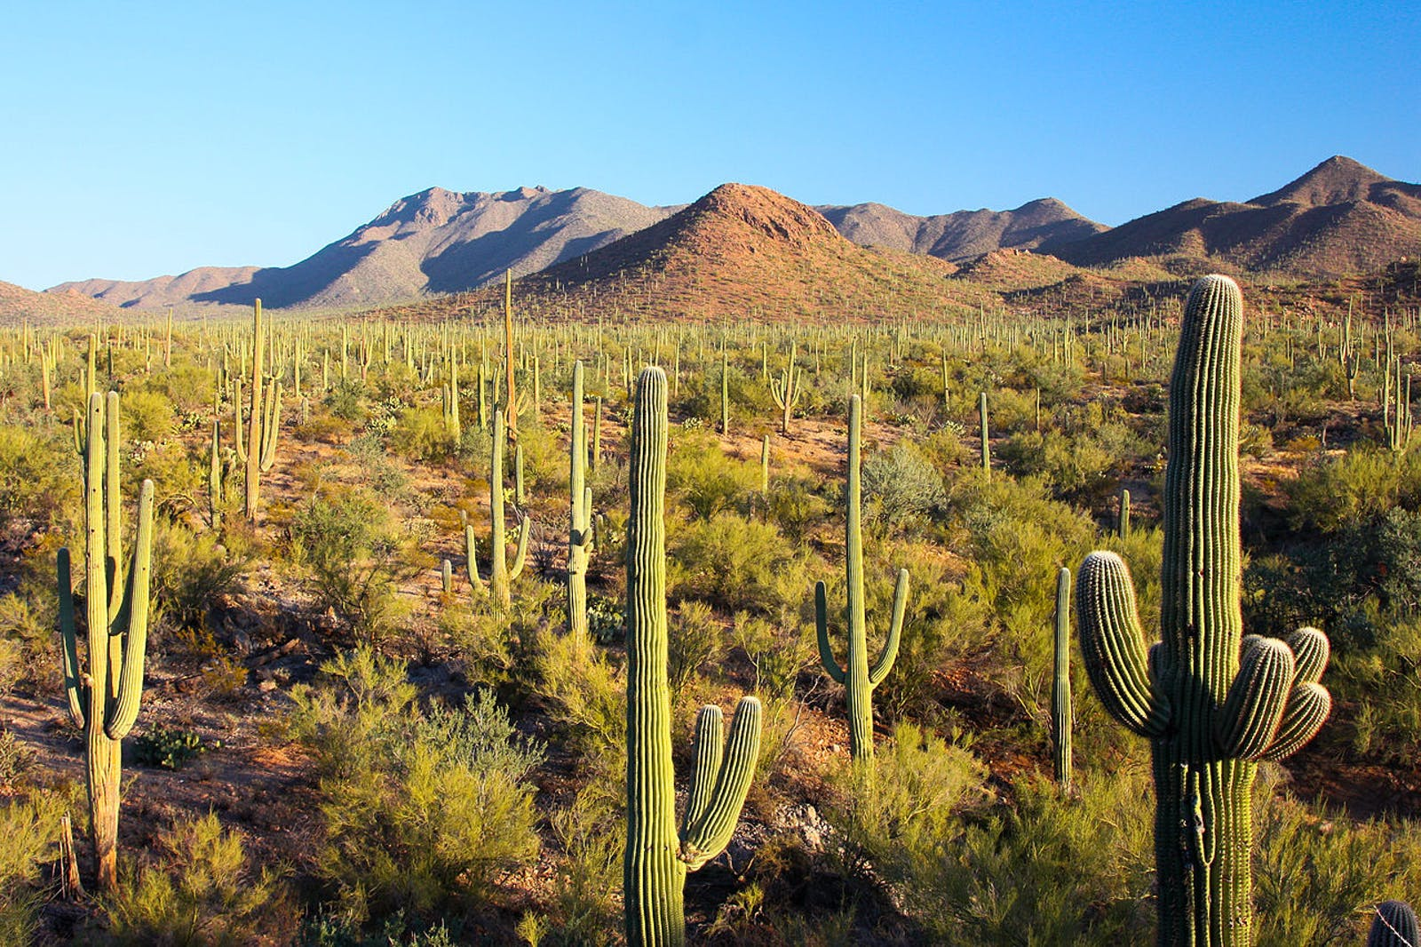
On the Edge
of the Desert

A project on the water table

Saudi over pumping is causing sink holes: https://www.azfamily.com/2024/12/11/attorney-general-sues-saudi-owned-farm-excessive-groundwater-pumping-western-arizona/

In the Ranegras Plain basin of La Paz County (where the Saudis have been pumping), state hydrologists found groundwater outflows exceeding natural recharge by about 900 percent, making it one of Arizona’s most overdrawn aquifers https://www.kawc.org/news/2025-11-06/arizona-takes-first-steps-on-water-protections-in-la-paz-county-basin

1. “Sinkhole Simulator” (Kinect/Body Interaction)

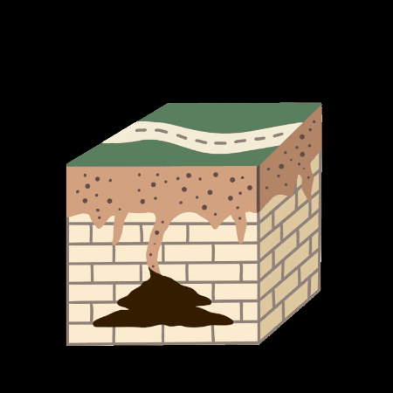

Some wells in these rural basins have dropped more than 90–140 feet over about 20 years, and in parts of Ranegras Plain more than 200 feet over 40 years, forcing residents to deepen or replace wells.
https://www.latimes.com/environment/story/2026-01-13/arizona-governor-water-crackdown

water use of datat centers: https://waterdesk.org/2025/04/data-centers-a-small-but-growing-factor-in-arizonas-water-budget/

2. Rate In Rate Out
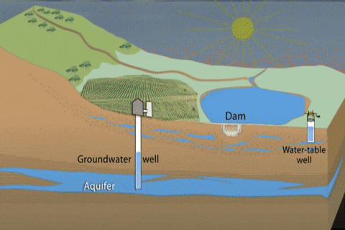

NASA article: https://science.nasa.gov/earth/earth-observatory/arizonas-declining-
groundwater-154567/

NASA data tools: https://www.earthdata.nasa.gov/data/tools

PRISM weather data https://www.prism.oregonstate.edu/
National Water Prediction Service: https://water.noaa.gov/#@=-96.401081,38.1465724,3.6832896&b=topographic&g=obsFcst,1!1!1!1!1!1!1!1!1!1!1!1!1!1!1!0!0!0!0!0,0.5,1!1!1!1!0,0,0,true&ab=0,0,#D94B4A,1,1,1,#cccccc,1,0,0,#B243B1,1,0,0,#98E09A,1,false&a=hydrologic,0.35,false&s=0,0,0.9,0.9,false&n=false,#72afe9,0.9,0,0.9,0,0.9,false&p=false,0.75,0,7,0,1,2026,1,27,0,false&d=0,0,1,1,1,1,1,1,#006EFF,1,#006EFF,1,#006EFF,false&q=
API for the National Water Predition Serfice: https://api.water.noaa.gov/nwps/v1/docs/

3. Water changes (AR/Touch App)
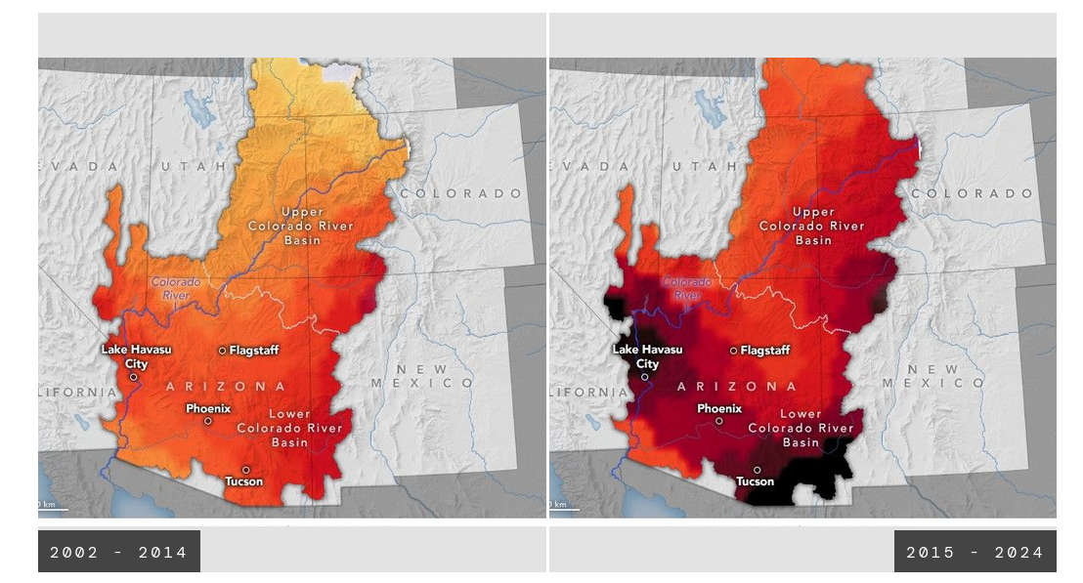
Concept: An AR phone/tablet app or wall projection that overlaysPRISM data on Arizona, or NWPS API data for live coverage, showing how much groundwater has been lost since over the decades.​ Can also use surface tempurateure, and you can change between years

4. aquafer sonification project

Your Arizona Water Footprint (AR)
A profile-based game where visitors “build” their Arizona lifestyle (home type, diet, crops) and see how much groundwater they consume, compared to how many “Arizona lifetimes” of groundwater would be needed to sustain their habits long-term, or the Ranegras Plain over-pump.​

physical map to explore with touch
https://vimeo.com/1093745
https://github.com/VIDILabs/code_swarm
https://www.youtube.com/watch?v=0fKBhvDjuy0
https://waterwhys.org/
https://astrobiology.arizona.edu/

Winslow Burleson

Dr Chris Impei

art workshop, showcase that is portable,

https://vimeo.com/1093745
https://github.com/VIDILabs/code_swarm
https://www.youtube.com/watch?v=0fKBhvDjuy0
https://waterwhys.org/
https://astrobiology.arizona.edu/

meadow@arizona.edu

